IOAI 2025 Individual Contest Day 1
Team Leader's Translation Version

Team Leaders must complete the form below, even if they don’t need translated documents.
Country Or Region | South Korea
Number of Team Members  （sample papers will be duplicated according to the number） | 4
How many pages in total  (cover pages included) | 26

IOAI2025 On Site Stage: Radar

Note: Please "join" the competition first. Then, you can mount the dataset to the GPU. Otherwise, the notebook may encounter an error because it cannot access the dataset until you have joined the competition.

1. Problem Description
레이더는 무선통신의 핵심 기술로 자율주행차과 같은 사례에서 광범위하게 활용되고 있다. 레이더 기술에는 일반적으로 특정 신호를 전송하고 환경의 물체로부터 반사되는 신호를 수신하는 안테나가 포함된다. 시스템은 이러한 신호를 처리함으로써 대상 물체의 각방향, 거리, 속도를 결정한다.
실제 응용 분야에서 레이더의 신호 처리는 주변 환경의 잡음과 외부 물체로부터의 반사로 인해 어려움이 있다. 예를 들어 보행자를 탐지하려고 할 때 레이더는 나무와 같은 외부 물체로부터 영향을 받아 정확도가 저하될 수 있다. 당신의 임무는 AI를 사용하여 레이더가 수신한 신호를 분석하고 각 위치에 사람이 있는지 확인해라
해당 task에서는 실내 레이더 실험 데이터셋을 제공하며, 당신의 목표는 레이더 semantic segmentation을 수행하는 모델을 개발하는 것이다.

2. Dataset
레이더를 둘러싼 물체를 측정하기 위해서는 다음과 같은 주요 파라미터가 사용된다:
- 범위 (Range): 레이더와 물체 사이의 직선 거리.
- 방위각 (Azimuth): 레이더와 물체 사이의 수평각 (왼쪽에서 오른쪽 방향으로).
- 고도 (Elevation): 레이더에 대한 물체의 수직각도 (위 또는 아래).
- 속도 (Velocity):물체가 레이더에게 가까워지거나 멀어지는 속도.
레이더 데이터는 여러 히트맵으로 처리되어 다양한 위치와 방향에서 수신된 신호의 강도를 각각 인코딩한다.
- Static heatmap은 정지된 객체로부터의 반사를 강조한다.
- Dynamic heatmap은 움직이는 객체에 의한 변화를 강조한다.
특정 위치에 물체가 존재하지 않을 때 신호는 대부분 배경 잡음으로 이루어져 약하게 보인다. 반대로 물체로부터의 반사는 신호 강도를 증가시켜 물체를 감지할 수 있게 한다.
예를 들어 static 범위-방위각 (Range-Azimuth) 히트맵은 주로 정지 물체에 의해 반사되는 서로 다른 거리 (범위 range)와 수평 각도 (방위 azimuth)에 걸친 신호 강도를 나타난다.
데이터셋의 각 샘플은 shape $7\times 50\times 181$의 텐서로.mat.pt 파일에 저장되는데, 여기서:
- 7은 맵의 수 (heatmap 6개 + semantic label map 1개) 이며,
- 50은 range bin (거리)을 나타내고,
- 181은 angular or velocity bin을 나타내며, 수평면 또는 수직면에서 -90°에서 +90° 까지의 각을 의미한다. 시각화의 일관성을 위해 velocity bin도 -90°에서 +90°로 리매핑된다고 가정해라
- 각 히트맵 intensity 값은 수신된 신호 강도를 나타내는 [0, 1]로 normalize된다.
6개의 히트맵은 다음과 같이 구성된다:
- Index 0: Static range-azimuth heatmap
- Index 1: Dynamic range-azimuth heatmap
- Index 2: Static range-elevation heatmap
- Index 3: Dynamic range-elevation heatmap
- Index 4: Static range-velocity heatmap
- Index 5: Dynamic range-velocity heatmap
히트맵의 모든 값은 normalize되기 때문에 단위 변환이 필요하지 않다.
Index 6에 해당하는 맵은 semantic label map이며, range-azimuth형식으로 저장된다.
- -1: 배경 (대상없음)
- 0: 여행 가방
- 1: 의자
- 2: 인간
- 3: 벽

This is the visualization of 1.mat.pt in training_set:
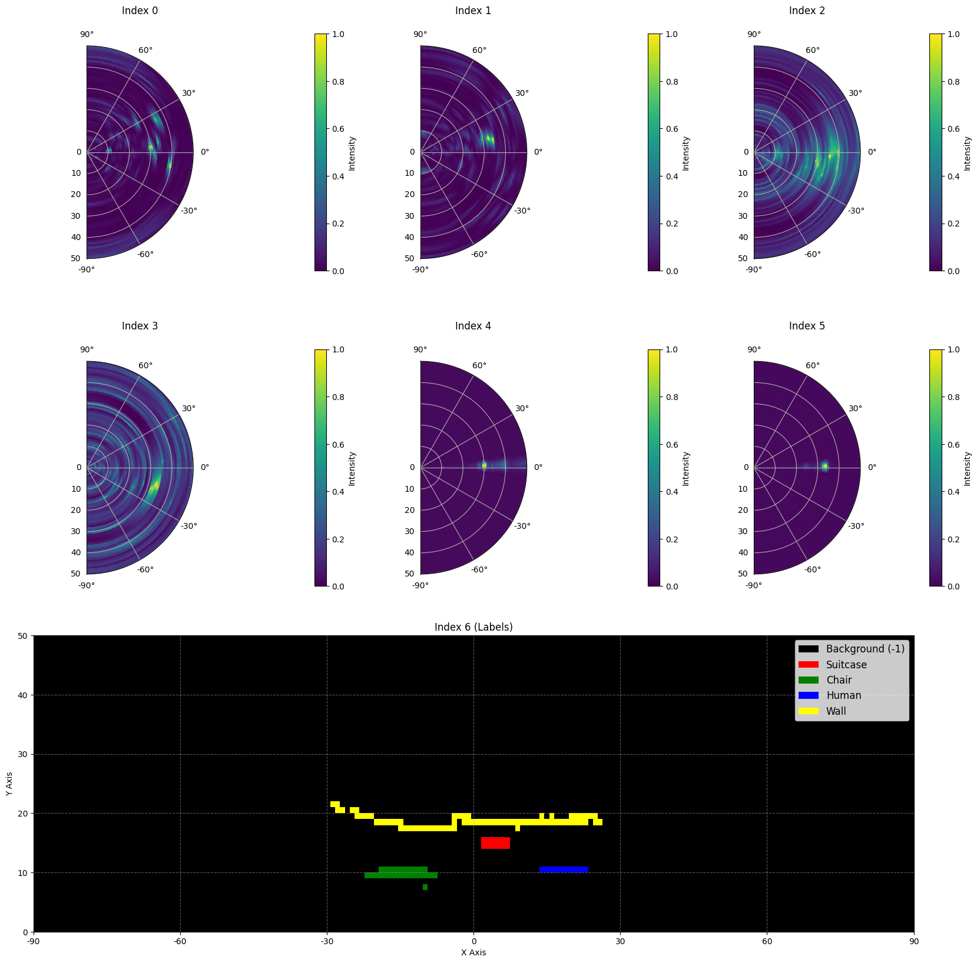

Here is part of a sample from the dataset:
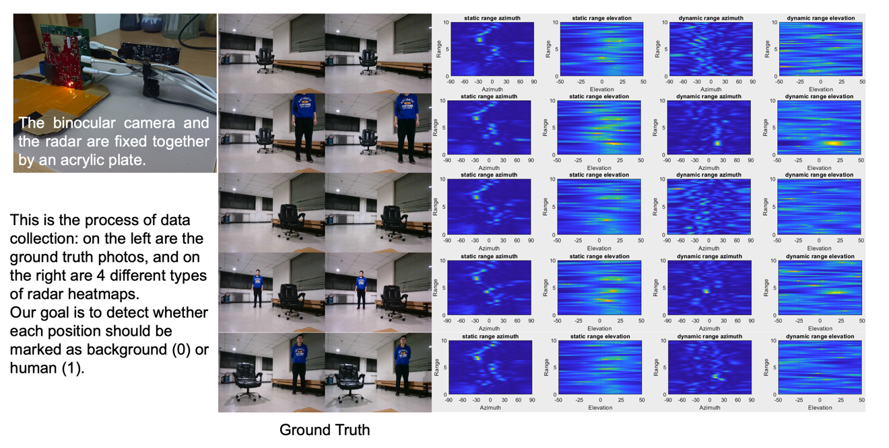
데이터 규모: training에 1800개 샘플, validation set에 500개 샘플, test set에 500개 샘플.

3. Task
Your task is to develop a model that takes the first six heatmaps (indices 0 to 5) as input, and predicts the semantic label map (index 6) as the output. The goal is to accurately identify what the target is(-1 to 3) at each location in the radar’s field of view.
- Input: A tensor of shape $6 \times 50 \times 181$, representing six radar heatmaps.
- Output: A tensor of shape $50 \times 181$, representing the target semantic label map.

4. Submission
Please submit a file named submission.ipynb. The output is a zip file named "submission.zip", which contains two tables submission_val.csv and submission_test.csv corresponding to the prediction results of the validation set and the test set respectively.
Note: The output table should have a header, the data in the table is not the actual solved data, it is only used as an example of the submission format.
문제 추가 공지: 아래의 0~9049의 테이블은tensor shape 50* 181로 입력될때 flatten되어 들어간다. (업데이트 된 영어 문제에도 이 내용이 있을 예정)
filename | pixel_0 | pixel_1 | ... | pixel_9049
1.mat.pt | -1 | -1 | ... | -1
... | ... | ... | ... | ...

5. Score
The score is based on the accuracy of label recognition. Correctly identifying target points is weighted more heavily than correctly identifying background points.

Scoring Criteria:
- Each correctly identified background pixel earns 1 point.
- Each correctly identified non-background pixel earns 50 points.
- The final score is normalized to a 0-1 point by comparing it to the maximum possible score.

Formula：
$$Score=\frac{\left|C_{0,correct}\right|×1+\left|C_{1,correct}\right|×bonus}{\left|C_{0}\right|×1+\left|C_{1}\right|×bonus}$$
where:
$$\begin{matrix}I & =\{1,2,…,50×181\} \\ C_{0} & =\{i∈I∣y_{i}=-1\} \\ C_{1} & =\{i∈I∣y_{i}≠-1\} \\ C_{0,correct} & =\{i∈C_{0}∣p_{i}=y_{i}\} \\ C_{1,correct} & =\{i∈C_{1}∣p_{i}=y_{i}\} \\ & \end{matrix}$$

Example
For a 3x3 heatmap, assume the Ground Truth is
$$\left[\begin{matrix}-1 & -1 & -1 \\ 1 & 2 & 3 \\ -1 & -1 & -1\end{matrix}\right]$$
The result you identified is
$$\left[\begin{matrix}-1 & 1 & -1 \\ -1 & 2 & -1 \\ -1 & 3 & -1\end{matrix}\right]$$
Then there are four correctly identified -1 and one correctly identified 2. Your score is 4 + 50 = 54 points. The maximum possible score is 6 + 50 * 3 = 156, that is, the score for six background pixels and three non-background pixels. Your normalized score is 54 / 156 = 0.346.
$$Score=\frac{4×1+1×50}{6×1+3×50}=0.346$$

6. Baseline and Training Set
- The baseline is in baseline.ipynb.
- The dataset is in training set.

7. Requirements
- Maximum submission limit: 15 times. Only successful submissions (i.e., those receive a score on Leaderboard A) will be counted toward the submission limit.
- Testing environment restrictions: The test machine will run your Notebook within 15 minutes. If the execution time exceeds 15 minutes, the system will forcibly terminate and return a feedback of “Timeout” or “Failed”.
- Data and model submission: In this task, contestants can only submit a Notebook and cannot submit any mounted datasets or .pth files generated by themselves. Please check the upper right corner to remove the mounted dataset first.
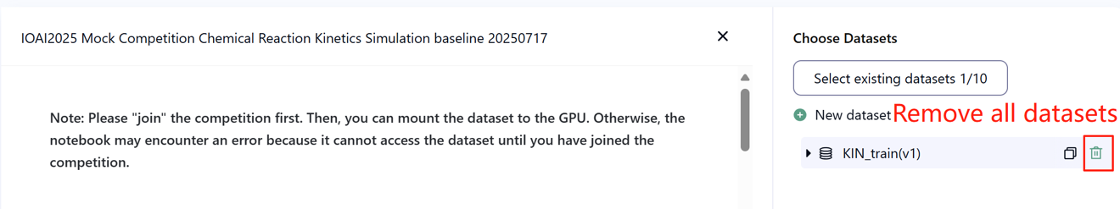
- Network: For the on-site stage, the test machine cannot connect to the internet. In other words, downloading commands such as 'pip' and 'conda' or trying to call APIs will not work.
- Pretrained Model: Any pre-trained model can be used in this task when it can be imported properly without network connection and downloading. This message means the Bohrium cannot guarantee to exclude all the pretrained model in the Python image when install the packages, when you find some useful ones, you can use them.

8. Precautions
- Which score is effective: Contestants can select up to 2 submission results for scoring (√ - selected， □ - not selected). The score before unification for this task will be determined by the higher score on the Leaderboard B among the two selected submissions. Other cases of score calculation: please refer to Appendix Platform Mechanisms and Restrictions for Individual Contest & GAITE.

- How to deal with ambiguity: Once there is a conflict between the task description and the training set, the validation set and test set , the dataset will be respected first, and the dataset will not be changed during the competition.
- Contestants can only access Leaderboard A during the contest and cannot access Leaderboard B. The final score will be calculated only based on the score in Leaderboard B.
- The highest score by the Scientific Committee for this task is 0.90 in Leaderboard B, this score is used for score unification.
- The baseline score by the Scientific Committee for this task is 0.67 in Leaderboard B, this score is used for score unification.

IOAI2025 On Site Stage: Chicken Counting Problem

Note: Please "join" the competition first. Then, you can mount the dataset to the GPU. Otherwise, the notebook may encounter an error because it cannot access the dataset until you have joined the competition.

1. Problem Description
당신은 Silkie 닭 농가와 협력하는 AI 연구팀의 리더로서 전통적인 방목 농업에서 중요한 과제를 해결하는 임무를 맡았다. 닭 개체수의 정확한 집계는 농가와 보험회사에게 중요한 통계이다. 질병과 포식자의 침입과 같은 요소들로 인하여 짧은 시간 내에 닭들의 생존율에 큰 영향을 줄 수 있기 때문이다. 또한 보험비용을 청구하는 과정에서 개체수의 손실을 정확하게 계산해야 한다. 농부들은 정확하고 자동화된 계산 시스템을 개발하는데 도움을 받기 위해 당신 팀에 접근했다. 농장 경영을 위해 density estimation technique을 이용하여 정확하게 개체수를 집계하는 모델을 개발해라.
당신의 팀은 Silkie 치킨 이미지를 위해 pretrained된 feature extractor를 사용할 수 있지만, 완벽한 집계 시스템을 만들기 위해 density estimation decoder을 설계하고 train해야 한다. 효과적인 decoder 구조와 training 방법을 고려하여 정확한 닭 집계 모델을 만들어라.
아래 그림은 데이터 세트의 이미지와 해당 실제 밀도 분포 (True density distribution) 및 baseline 모델에 의해 예측된 밀도 분포(predicted density distribution)를 보여준다. 전체 밀도 (모든 영역의 밀도의 합) 이라는 레이블이 표시된다.
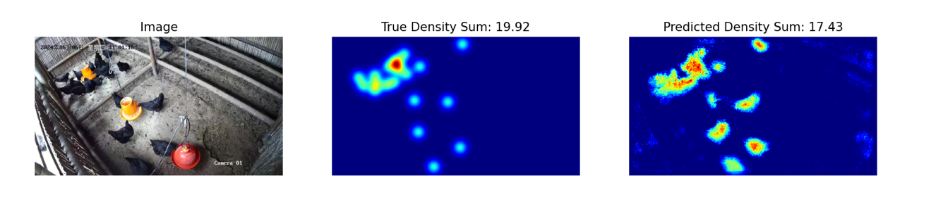

2. Dataset
The structure of the provided Silkie chicken image dataset is as follows:
datasets/
├── train/
│ └── A dataset with features:
│ ├── `image`: `PIL.Image` with RGB channels (3x720x1280)
│ └── `density`: a 2D array of shape 180x320
└── base.pth (Pretrained Model)
os.environ.get("DATA_PATH")/
├── test_a/
│ └── A dataset with features:
│ └── `image`: `PIL.Image` with RGB channels (3x720x1280)
└── test_b/
└── A dataset with features:
└── `image`: `PIL.Image` with RGB channels (3x720x1280)
(1) Training set location: datasets, files in this folder are used for model fine-tuning. It contains a train folder, which stores a dataset with 100 images and their corresponding density maps.
(2) Validation set (test_a) and Test set (test_b): These will be used to evaluate scores on Leaderboard A and Leaderboard B, respectively. They will be inaccessible to contestants. Only the score achieved on test set B will be used for final scoring.
(3) Datasets size:
- Training set: 100 images.
- Validation set: 100 images.
- Test set: 100 images.
(4) Validation set (test_a) and Test set (test_b) are not visible.
(5) Due to limits of computing resources, training density maps are reshaped to $1×180×320$. NOTE the output density map can be viewed as a 2D real number matrix with shape $180×320$, the sum of all matrix values is the count of chickens.

3. Task
Your task is to train your own model using the training data to predict density maps, thereby serving the purpose of chicken counting.
You may extend and optimize the given pretrained model to improve its count prediction accuracy. The pretrained model base.pth only contains the weights of the first four layers of the model (the feature extraction model), and the function load_pretrained_weights_partial in the baseline code can be used to load these partial weights into your model. You may construct a density decoder Density Decoder and combine it with the pretrained feature extraction module to form a complete data prediction model.
class DensityDecoder(nn.Module):
def __init__(self):
#################################################
# Your code here
#################################################
def forward(self, x):
#################################################
# Your code here
#################################################
return x
You can also build your own model without the pretrained model we provided.
This task is the continuation of Satellite Weather Forecasting. A kind remind is the UNET is easily to full GPU memory without any feature engineering. Then, the GPU memory error message will be reported.
Please follow these rules to achieve a score normally:
(1) Your model must output the predicted density map.
(2) Due to limits of computing resources, your output density map should be reshaped to $180×320$. This is also the shape of target density maps provided in the train dataset.

4. Submission
Please submit a submission.ipynb that includes the following components:
（1）Training Code
- Include the full training pipeline.
（2）Evaluation Code
- Evaluate your model on the validation set and test set. Refer to baseline.ipynb on how to access these datasets with a secret DATA_PATH.
- The output should be saved as submission.npz. This must be a valid npz file containing two arrays pred_a and pred_b, each with shape 100x1x180x320 (The evaluation script will also accept predictions in the shape of 100x180x320, if you decide to squeeze the channel dimension).
- Any result that does not meet the specified size will be considered invalid, resulting in an assessment score of zero.
- Each element of the density map should be no less than zero, otherwise will result in an assessment score of zero.

5. Score
You will be scored based on the mean relative error of your model. Relative error is defined by:
$$\text{Relative Error=}\frac{\left|y_{i}-{\hat{y}}_{i}\right|}{\left|y_{i}\right|}$$
where $y_{i}$ is the true total density for the i-th sample, and ${\hat{y}}_{i}$ is the predicted total density for the i-th sample.
Your final score before normalization will be calculated based on your mean relative error, as follows:
$$\text{Score=}\text{exp}\left(-\frac{1}{n}\sum_{i=1}^{n}{\frac{\left|y_{i}-{\hat{y}}_{i}\right|}{y_{i}}}\right)$$

6. Baseline & Training Set
The baseline is in baseline.ipynb.
The training set is in training set.

7. Requirements
- Maximum submission limit: 15 times. Only successful submissions (i.e., those receive a score on Leaderboard A) will be counted toward the submission limit.
- Testing environment restrictions: The test machine will run your Notebook within 15 minutes. If the execution time exceeds 15 minutes, the system will forcibly terminate and return a feedback of “Timeout” or “Failed”.
- Data and model submission: In this task, contestants can only submit a Notebook and cannot submit any mounted datasets or .pth files generated by themselves. Please check the upright corner to remove the mounted dataset first.

- Network: For the on-site stage, the test machine cannot connect to the internet. In other words, downloading commands such as 'pip' and 'conda' or trying to call APIs will not work.
- Pretrained Model: You may use the provided pretrained weights at base.pth, but it's not a must.
- Any other pretrained model can be used in this task when it can be imported properly without network connection and downloading. This message means the Bohrium cannot guarantee to exclude all the pretrained model in the Python image when install the packages, when you find some useful ones, you can use them.

8. Precautions
- Which score is effective: Contestants can select up to 2 submission results for scoring (√ - selected， □ - not selected). The score before unification for this task will be determined by the higher score on the Leaderboard B among the two selected submissions. Other cases of score calculation: please refer to Appendix Platform Mechanisms and Restrictions for Individual Contest & GAITE.

- How to deal with ambiguity: Once there is a conflict between the task description and the training set, the validation set and test set , the datasets will be respected first, and all the datasets will not be changed during the competition.
- Contestants can only access Leaderboard A during the contest and cannot access Leaderboard B. The final score will be calculated only based on the score in Leaderboard B.
- The highest score by the Scientific Committee for this task is 0.89, this score is used for score unification.
- The baseline score by the Scientific Committee for this task is 0.71, this score is used for score unification.

IOAI2025 On Site Stage: Concepts

Note: Please "join" the competition first. Then, you can mount the dataset to the GPU. Otherwise, the notebook may encounter an error because it cannot access the dataset until you have joined the competition.

1. Problem Description
Concept는 플레이어가 시각적인 아이콘을 통해 아이디어를 전달하는 단어 추측 게임이다. Clue-Giver와 Guesser이라는 두 가지 역할이 있다. 두 플레이어에게 동일한 아이콘 set가 주어진다 아래는 예시이다:

Clue-Giver는 먼저 하나 혹은 여러 단어를 비밀로 (정답) 지정한 다음 아이콘 set에서 아이콘을 sequence로 가리킴으로써 비밀에 대한 힌트를 제공한다 - 말하기 또는 쓰기는 허용되지 않는다.
힌트의 아이콘 순서에게는 아래와 같은 의미가 있다:
- 첫 번째 아이콘은 일반적으로 정답의 핵심 아이디어를 나타낸다.
- 후속 아이콘들은 첫 아이콘에서 주어진 핵심 아이디어를 더 자세히 설명하거나 명확하게 한다.
Example 1
다음 힌트는 장소이지만, 직업이기도 하고, 싸운다, 불과 – 소방서로 해석된다

하지만 아이콘 순서가 뒤바꿔 보자 - 직업이지만, 싸운다, 불과, 집에서 - 해석되어 소방관을 의미 할 수 있다

Example 2
아이콘은 문맥에 따라 다른 의미를 가질 수 있다. 아래 예시를 보자: 도구이지만, 의료 관계자가 사용하고, 귀를 사용하고, 하트(심장)가 관련있다 -- 청진기로 하트는 심장을 의미하지만

아래 예시에서는 – 가상 인물이지만, 죽음에 관련됐고, 생명에 관련있기에 – 좀비로 해석되어 해당 예시에는 하트는 생명을 의미한다.


홈 스테이지에서는 이미 힌트의 순서에 따라 결과를 예측하는 AI 프로그램을 개발했다. 하지만 당신의 친구가 "추측은 쉽지만, 좋은 단서도 줄 수 있는 AI 시스템은 못만들걸?" 도발해온다. 그들은 더 나아가 다른 AI 시스템이 당신의 키워드를 추측할 수 있도록 좋은 단서를 제공하는 AI 시스템을 만들라고 도전했다!
도전을 좀 더 흥미롭게 하기 위해 지금부터 다른 Concept 게임을 한다. 이전 Concept게임은 단서가 하나의 시퀀스의 마커로만 구성될 수 있도록 단순화되었다.
이제부터 최대 4시퀀스의 마커를 제공할 수 있다!
이것으로 우리는 복잡한 생각을 더 잘 표현할 수 있다. 사무라이를 설명하기 위해 3개의 마커 시퀀스를 이용하는 다음을 고려하면: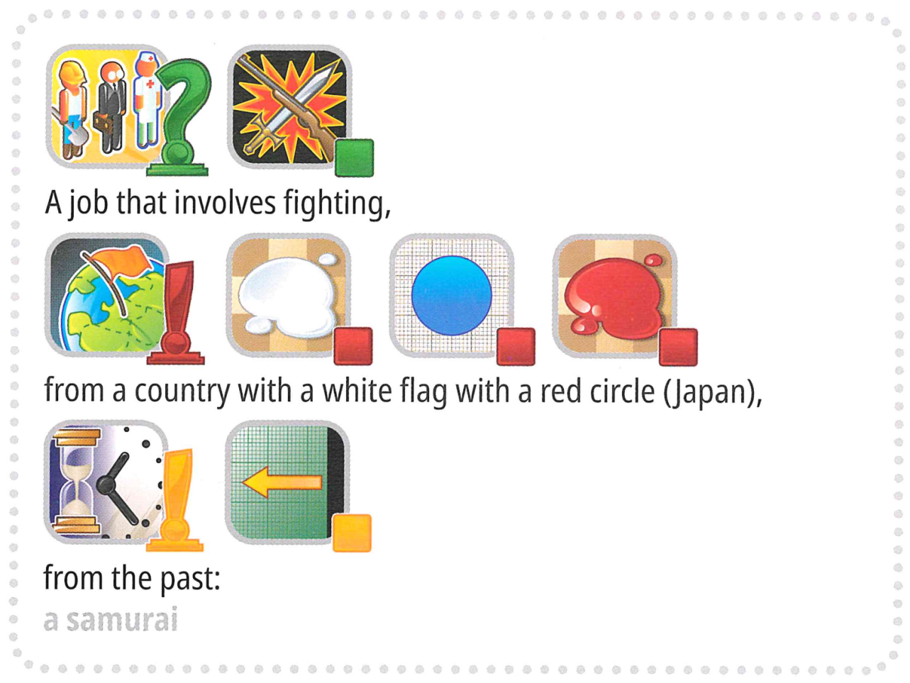
But wait, there's more. To make the challenge even more interesting, the game will now include some keywords that are not typically present in a Concept game, such as "International Olympiad."
Are you up to the challenge?

New AI-Powered Format:
We've replaced the human guesser with an AI Guesser. To streamline game play:
- The target word (label) will always be selected from a predefined set (options).
- Hints must be an ordered sequence of markers chosen exclusively from a fixed set of 118 candidate markers.

Terminologies
To ensure clarity and consistency, we are standardizing key terms across all materials.
- label: The target answer (or "secret") to be identified.
- options: The predefined candidate set from which all valid labels are selected.
- marker: An icon representing a concept, accompanied by its text description.
- hints: An ordered sequence of markers provided to the AI guesser to help identify the label.
Your task is to provide hint for each label to help the AI guesser identify it. For example, when the target label is "microphone", your program may generate four hint sequences like:
- Hint 1:
["Object-Box", "Electronic-Computing", "Mouth-Taste", "Ear-Sound-Hearing", "Tool-Construction"]
- Hint 2:
["Music-Song", "Television-Program-Show", "Work-Occupation", "Use - Action-Do - Verbe-Button"]
- Hint 3:
["Black", "Metal", "Plastic-Rubber", "Cylinder", "Circle-Ring"]
- Hint 4:
["Arm-Hand-Finger", "Happy-Positive", "Expression - Quote-Talking-Words", "Life-Heart-Love"]
Note: The above example is for illustrative purposes only. The program should generate lists of IDs but not strings; please refer to both `3. Task` and the baseline.

2. Dataset
The structure of the provided dataset is as follows:
datasets/
├── train/
│ └── A huggingface dataset
└── hint_descriptions/
└── A huggingface dataset
os.environ.get("DATA_PATH")/
└── test/
├── test_a/
│ └── A huggingface dataset
└── test_b/
└── A huggingface dataset
- Training set: files in this folder are used for model training. It contains:
  - train/: A huggingface dataset with a single split 'train', with 30 examples, each containing:
    - label: string - the target keyword/answer
    - options: sequence of strings - list of 100 possible choices
  - hint_descriptions/: A huggingface dataset with a single split 'train', with 118 markers and their descriptions:
    - ID: int64 - unique identifier for each marker
    - Description: string - textual description of what the marker represents
    - image: Image - visual representation of the marker
- Test sets: Located at os.environ.get("DATA_PATH")/test/. These will be inaccessible during development and will only be available in the evaluation environment:
  - test_a/: A huggingface dataset with a single split 'test' containing 150 examples for leaderboard A evaluation
  - test_b/: A huggingface dataset with a single split 'test' containing 150 examples for final scoring
Both test datasets contain the same structure as the training set (label and options fields).

3. Task
Your task is to provide hint for each label to help the AI guesser identify it. You are required to develop a program that takes two inputs:
- A string label (your secret label)
- The options list (100 candidate choices for the guesser)
The label is guaranteed to be one of the options.
Additionally, the program will utilize the predefined candidate markers.
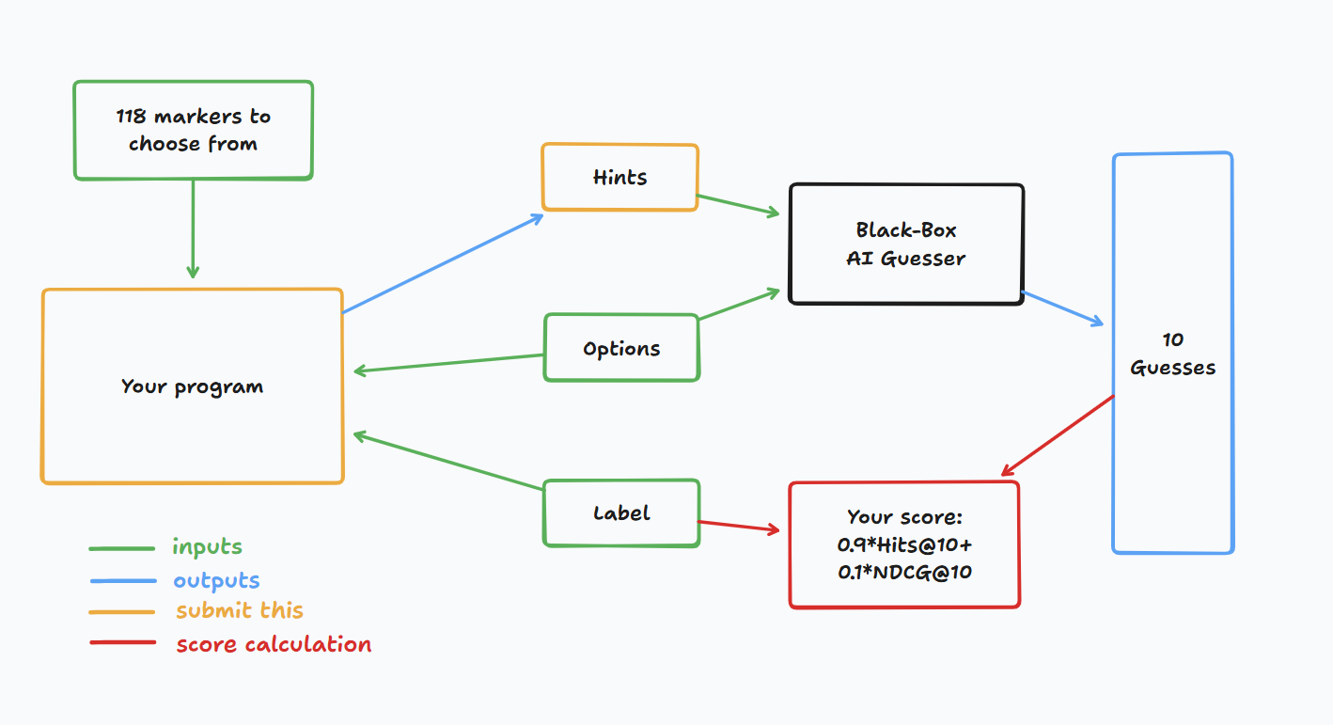
This program should return a list of lists of integers for each label, representing the hints(i.e. the sequences of markers). Specifically:
- The returned list must contain no more than 4 sequences.
- Each sequence can contain up to 8 integers.
- Each integer represents the ID of a marker in the clue.
Your hints will then be given to a black-box AI guesser. You will score a point if the black-box AI guesser can correctly guess your secret keyword based on your hints.

4. Submission
Submit a notebook that generates submission.zip, which includes clues_a.jsonl and clues_b.jsonl, the clues for testset a and b, respectively, in json format. Refer to the baseline notebook for how to generate these files and the specific structure of the jsonl files. Please make sure to follow the naming and structuring conventions.
Contestants may submit model files. If submitting model files, contestants must create a corresponding dataset on the Bohrium platform. Only one dataset can be submitted for this task, and its size must not exceed 2GB. Preloaded datasets and models will be automatically mounted on the test machine, eliminating the need for manual mounting during submission.
Additionally, contestants are permitted to use larger external models to assist in developing their submission.

5. Score
Your clue is evaluated using two metrics:

Hits@10
= 1 if the secret word is in the top 10 guesses from the AI, else 0.

NDCG@10 (Normalized Discounted Cumulative Gain)
Rewards the correct guess more if it appears higher in the list.
If the secret word is at rank i (1-based):
$$\text{NDCG@10}=\frac{1}{\log_{2}(i+1)} \text{(1)}$$
Examples:
- Rank 1 → 1.00
- Rank 2 → ~0.63
- Rank 4 → ~0.43
- Rank 10 → ~0.29

Final Score
Your final score will be a combination of both, specifically, it will be 0.9 Hits@10 + 0.1 NDCG@10.
The scoring means that you'll get a significant point as long as the guesser can guess the secret keyword correctly, but more point is given if the guesser can predict the secret keyword earlier.

6. Baseline & Available Tools
- The baseline is in baseline.ipynb
- The training set and pretrained models are in training set

AI-Guesser API
You can assess the AI-guesser for you to play around with. See the following code on how to access the guesser. It is recommended to implement exponential retry logic as network failures might occur. For more comprehensive code, refer to the baseline.ipynb.
guesser_response = httpx.post(f"{API_URL}/guess", json={
"clues": clues,
"options": options
}, headers={
"Authorization": f"Bearer {SCORER_API_KEY}"
}, timeout=60).json()
Important: The AI-Guesser API will not be available on the inference machines. In other words, do NOT call the api in your submission notebooks. This is only for you to validate/train your model locally. You may attach your model weights, training data, etc. via a Bohrium dataset. Refer to the Requirements section.

Environment
We installed vllm, sglang and unsloth in environment for LLM inference and fine tuning.
Additionally, we provide access to the following huggingface models via a training set in Bohrium platform:

Embedding Models
sentence-transformers/all-MiniLM-L6-v2
sentence-transformers/all-MiniLM-L12-v2
sentence-transformers/all-mpnet-base-v2
sentence-transformers/paraphrase-mpnet-base-v2
sentence-transformers/paraphrase-MiniLM-L6-v2
intfloat/e5-small
intfloat/e5-base
intfloat/e5-large
intfloat/e5-small-v2
intfloat/e5-base-v2
intfloat/e5-large-v2
intfloat/multilingual-e5-small
intfloat/multilingual-e5-base
Alibaba-NLP/gte-modernbert-base
Snowflake/snowflake-arctic-embed-xs
Snowflake/snowflake-arctic-embed-s
Snowflake/snowflake-arctic-embed-m
Snowflake/snowflake-arctic-embed-m-long
Snowflake/snowflake-arctic-embed-l
BAAI/bge-large-en
BAAI/bge-base-en
BAAI/bge-small-en
BAAI/bge-large-en-v1.5
BAAI/bge-base-en-v1.5
BAAI/bge-small-en-v1.5
WhereIsAI/UAE-Large-V1
mixedbread-ai/mxbai-embed-large-v1

Small LLMs
Qwen/Qwen3-0.6B
Qwen/Qwen2.5-0.5B
Qwen/Qwen2.5-0.5B-Instruct
unsloth/Qwen3-0.6B
facebook/opt-350m
facebook/opt-125m
You may refer to huggingface models tutorial for how to load successfully load these local models.

LLM Proxy Access
We provide a LLM proxy. Reference llm proxy tutorial for how to access the proxy. Note that you will have a $10 credit limit. As a reminder, you are not allowed to use private APIs, login to any external services (including huggingface), or use your own tokens for any service.
Important: The LLM proxy will not be accessible on the test machines. If your submitted notebook tries to call the api, it will not run.

7. Requirements

Overall Requirements
- Maximum submission limit: 15 times. Only successful submissions (i.e., those receive a score on Leaderboard A) will be counted toward the submission limit.
- Testing environment restrictions: The test machine will run your Notebook within 10 minutes. If the execution time exceeds 10 minutes, the system will forcibly terminate and return a feedback of “Timeout” or “Failed”.
- Data and model submission: In this task, participants should submit a Notebook and have the option to submit 1 attached dataset generated by themselves. The dataset must not exceed 2GB in total size. You are warned that attaching a very large dataset might prolong the testing process, as the dataset needs to be mounted to the inference machine. While this process does not count towards the execution time limit, it will take longer for you to be able to see and select your submissions.
- Network: For the on-site stage, the test machine cannot connect to the internet. In other words, downloading commands such as 'pip' and 'conda' or trying to call APIs will not work. Specific to this problem, the testing machines cannot access the guessor API nor the LLM proxy.

API Access Limitations
Your token will grant you 12,500 POST requests to /guess endpoint of the AI-guesser API.
문제 추가 공지: 한 사람당 총 12,500 request 이상 넘어가면 안되고, 분당 1000 request를 요청하면 fail 된다.
- If successful, this will return a dictionary in the form {'guesses': ['firefighter', 'fire inspector', 'fire marshal', 'fire warden', 'fire safety officer', 'smokejumper', 'pyrotechnician', 'firewatcher', 'chef', 'cook'], 'message': 'Generated 10 guesses'}.
- If unsuccessful, this will either raise an HTTPStatusError and return {'detail': 'error message'}, or return {'guesses': [], 'message': 'unable to generate guesses'}.
- Usually, the former is because you have exceeded the 12,500 limit of your token, or you tried to make more than 1000 requests within 1 minute, and the latter is because your clues exceeded 4 sequences or exceeded 8 markers in 1 sequence.
- Refer to the error message for details.
- There might be 1-2 failures in 1000 requests, 'retry' mechanism is provided in baseline.ipynb.

Warning
The scientific committee will closely monitor the submission notebooks for this problem. Any intentional attempts at trying to obtain the testing set will get you disqualified.

8. Precautions
- Which score is effective: Contestants can select up to 2 submission results for scoring (√ - selected， □ - not selected). The score before unification for this task will be determined by the higher score on the Leaderboard B among the two selected submissions. Other cases of score calculation: please refer to Appendix Platform Mechanisms and Restrictions for Individual Contest & GAITE.

- How to deal with ambiguity: Once there is a conflict between the task description and the training set, the validation set and test set , the dataset will be respected first, and the dataset will not be changed during the competition.
- Contestants can only access Leaderboard A during the contest and cannot access Leaderboard B. The final score will be calculated only based on the score in Leaderboard B.
- The highest score by the Scientific Committee for this task is 0.54, this score is used for score unification.
- The baseline score by the Scientific Committee for this task is 0.20, this score is used for score unification.

<< FINAL PAGE >>

<< FINAL PAGE >>

